PHARMACY MANAGEMENT SYSTEM DATABASE
Student Name: JOYCE MUTINDI MUASYA
Registration Number: D3/3468/2023
Pharmacy_db

ER DIAGRAM
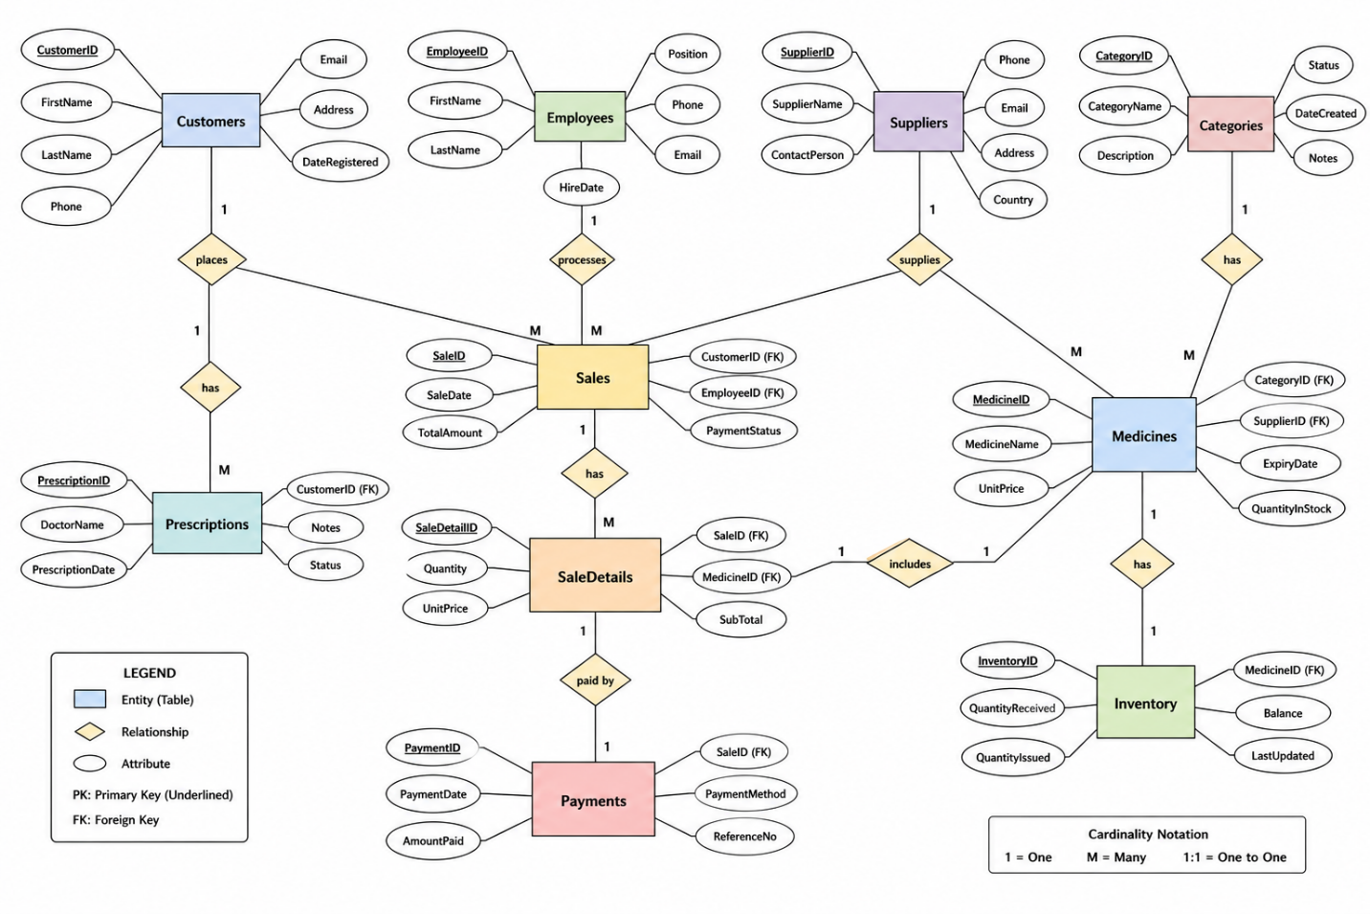

PART A: DATABASE DESIGN AND TABLE CREATION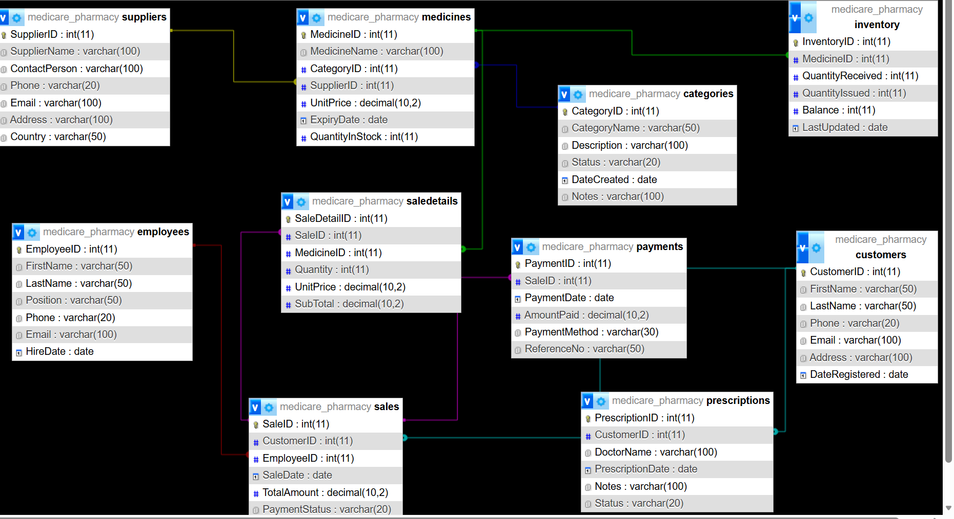

PART B: RELATIONSHIPS (ER DIAGRAM) Description
Customers → Sales (1:M)
Employees → Sales (1:M)
Sales → Sale Details (1:M)
Medicines → Sale Details (1:M)
Categories → Medicines (1:M)
Suppliers → Medicines (1:M)
Sales → Payments (1:1)
Medicines → Inventory (1:1)
Customers → Prescriptions (1:M)


PART C: SQL QUERIES AND REPORTS
Query 1: Create Customer Table
CREATE TABLE Customers (
Customer ID INT PRIMARY KEY AUTO_INCREMENT,
FirstName VARCHAR (50),
LastName VARCHAR (50),
Phone VARCHAR (20),
Email VARCHAR (100),
Address VARCHAR (100),
Date Registered DATE
);
Output Screenshot:
Insert screenshot here

Query 2: Insert Record into Customers Table
INSERT INTO Customers (FirstName, LastName, Phone, Email, Address, Date Registered)
VALUES ('Jane', 'Wanjiku', '0722222222', 'jane@gmail.com', 'Nairobi CBD', '2026-04-10');
Output Screenshot:
Insert screenshot here

Query 3: Retrieve Customers Registered in April 2026
SELECT *
FROM Customers
WHERE MONTH (Date Registered) = 4
AND YEAR (Date Registered) = 2026;
Output Screenshot:
Insert screenshot here

Query 4: Retrieve Customers Who Made Purchases (Sales Report)
SELECT
c. Customer ID,
c. FirstName,
c. LastName,
s. Sale ID,
s. Sale Date,
m. Medicine Name,
sd. Quantity
FROM Customers c
JOIN Sales s ON c. Customer ID = s. Customer ID
JOIN Sale Details sd ON s. Sale ID = sd. Sale ID
JOIN Medicines m ON sd. Medicine ID = m. Medicine ID;
Output Screenshot:
Insert screenshot here

PART D: DATA ENTRY FORMS
CUSTOMER FORM
FIELD | INPUT
Customer ID
First name
Last name
Phone
Email
Address
Date registered

EMPLOYEES FORM
FIELD | INPUT
Employee ID
First name
Last name
Position
Phone
Email
Hire date

SUPPLIERS FORM
FIELD | INPUT
Supplier ID
Supplier name
Contact person
Phone
Email
Address
country

CATEGORIES FORM
FIELD | INPUT
Category ID
Category name
Description
Status
Date created
notes

MEDICINES FORM
FIELD | INPUT
Medicine ID
Medicine name
Category | From categories
supplier | From supplier
Unit price
Expiry date
Quantity in stock
Stock value(derived) | Unit price*quantity

PRESCRIPTIONS FORM
FIELD | INPUT
Prescription ID
Customer | From customers
Doctor name
Prescription date
Notes
status

SALES FORM
FIELD | INPUT
Sale ID
Customer | From customer
employee | From employees
Sale date
Total amount | From sale details
Payment status

SALE DETAILS FORM
FIELD | INPUT
Sale detail ID
Sale ID
medicine | From medicines
Quantity
Unit price
Subtotal(derived) | (quantity*unit price)

PAYMENTS FORM
FIELD | INPUT
Payment ID
Sale ID
Payment date
Amount paid
Payment period
Reference No

INVENTORY FORM
FIELD | INPUT
Inventory ID
medicine | From medicine
Quantity received
Quantity issued
Balance (derived) | (received-issued)
Last updated

PART E: KEYS IDENTIFICATION
table | Candidate key(s) | Super key(S) | Foreign key(s)
Customers | Customer ID | {Customer ID}, {Customer ID + Phone}, {Customer ID + Email} | None
Employees | Employee ID | {Employee ID}, {Employee ID + Phone}, {Employee ID + Email} | None
Suppliers | Supplier ID | {Supplier ID}, {Supplier ID + Supplier Name} | None
Categories | Category ID | {Category ID}, {Category ID + Category Name} | None
Medicines | Medicine ID | {Medicine ID}, {Medicine ID + Medicine Name} | Category ID, Supplier ID
Prescriptions | Prescription ID | {Prescription ID}, {Prescription ID + Prescription Date} | Customer ID
Sales | Sale ID | {Sale ID}, {Sale ID + Sale Date} | Customer ID, Employee ID
Sale details | Sale Detail ID | {Sale Detail ID}, {Sale ID + Medicine ID + Quantity} | Sale ID, Medicine ID
Payments | Payment ID | {Payment ID}, {Payment ID + Reference No} | Sale ID
Inventory | Inventory ID | {inventory ID}, {medicine ID+ last updated} | Medicine ID

